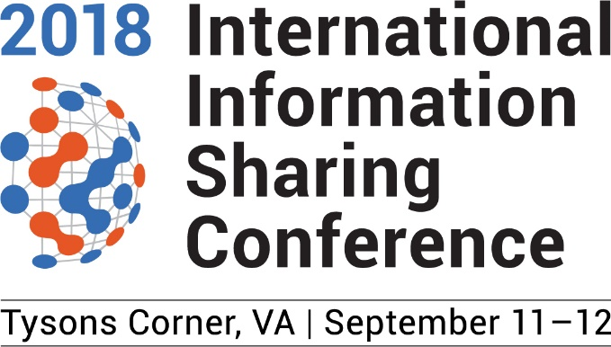

Subject: Request to Attend IISC Conference 2018

Dear [DecisionMakerName],

The International Information Sharing and Analysis Conference for 2018 takes place on September 11th and 12th at the Hilton McLean Tysons Corner in Virginia. The theme for the 2018 conference is "Improving Information Sharing". It is regarded as the world’s leading forum for enterprise and technical information sharing security professionals.

Attendance at the International Information Sharing and Analysis Conference will provide the following benefits:

- More than several sessions to help build knowledge, skills, and value in the following topic areas:
- Government & Legislation Issues Impacting Information Sharing
- Improving the Value of Shared Information
- What’s Trending Hot in the Information Sharing Ecosystem
- Growing Your ISAO in the Ecosystem
- The ability to meet face to face with my professional peers and experts in information sharing and analyses.
- Ensuring myself and our organization are up to date with the most current industry information, insights, and innovations.
- An opportunity to share the knowledge I gain with colleagues and immediately implement new skills
- Access to key partners and sponsors. I’ll have access to product demos and get 1-to-1 face time with sponsors.

The approximate costs for my attendance:
Flight $XXX
Transportation (round trip from airport to hotel) $XXX
Hotel (2 nights at $250 per night*) $XXX
Meals (2 days at $XX per diem) $XXX
Full Conference Pass (2 days) $295†
Total cost to attend: $XXXX

*The Conference has specially negotiated hotel rates for attendees at $250/night. Use the following link to book your room(s): https://aws.passkey.com/event/49587634/owner/3114104/home

†This registration rate is discounted providing I register before May 31, 2018.

Please let me know if you would like me to provide additional information. More details are also available on the Information Sharing and Analysis Organization's web site. Thank you for your consideration.

Sincerely,

[YourName]

